- In our view, the UK economy remains exceptionally fragile; subdued growth and high inflation (mild stagflation), and a weak fiscal position are set to persist as a sustainable driver of UK growth has yet to emerge.
- The Budget may contribute to the headwinds. Media speculation that the UK risks a 1970s-style fiscal crisis is overstated. But the fiscal situation is poor and, as recent weeks have shown, UK bond yields are particularly vulnerable to swings in market sentiment.
- We think the government will need to tighten policy by around £30bn in November to stay compliant with its fiscal rules. We expect the freeze on tax thresholds and allowances to be extended beyond fiscal year 2027-2028, with more narrowly focused tax hikes biting sooner.
- More interest rate cuts are likely, but given the Monetary Policy Committee's concerns about the strength of underlying inflationary pressures and that rates are moving closer to neutral territory, we expect it to adopt a more cautious approach.
- We anticipate the MPC skipping a November rate cut and expect Bank Rate to end next year at 3.5%, 50bps higher than our previous forecast but still below current market pricing.
The UK enjoyed the strongest H1 GDP growth in the G7, growing by 1.9% on an annualised basis. But we regard this as an anomaly rather a sign that the UK economy has emerged from years in the doldrums. The competition was scarcely fierce – three of the other countries scraped above 1% and the remaining three were well below. We also think the UK's performance was flattered by ongoing problems with residual seasonality in the GDP series. For each of the past three years, activity growth was strong in the early months of the year before petering out in the second half (Chart 1).
So far, the 2025 experience has closely matched earlier years. We think there's strong grounds to expect this to continue, so we forecast annualised growth of just 0.6% in H2. Our calendar-year growth forecast of 1.3% represents a better guide to the underlying strength of the UK economy than the stronger H1.
Chart 1: We think residual seasonality flattered the performance of the UK economy in H1
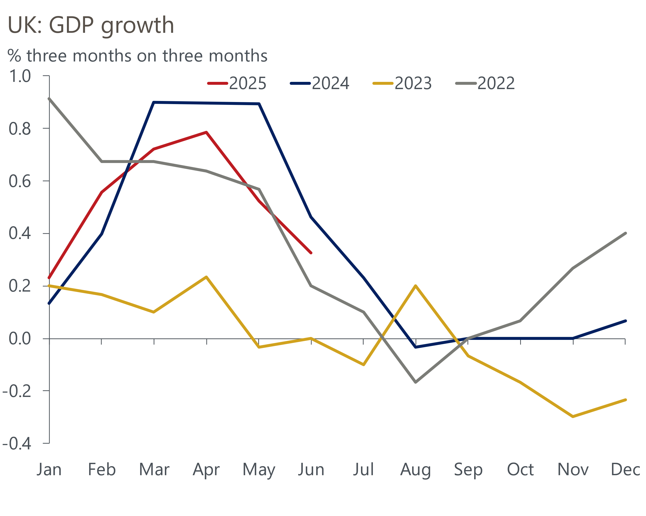
Sources: Oxford Economics, Haver Analytics

We expect a slight loss of momentum as we move into 2026. Our forecast that the economy will grow by 0.9% is slightly weaker than the consensus' 1.1% and the Bank of England's latest forecast of 1.25%.

Domestic headwinds will subdue the pace of growth
Our relative pessimism is largely based on the strength of domestic headwinds. We calculate that fiscal policy is being tightened to a greater extent in the current fiscal year than in any of the past 15 years except the pandemic period (Chart 2). Though the squeeze will be smaller next year, we estimate it will still be comparable to the most austere years of the 2010-2015 coalition government.
Chart 2: Fiscal policy is being tightened significantly this year and next
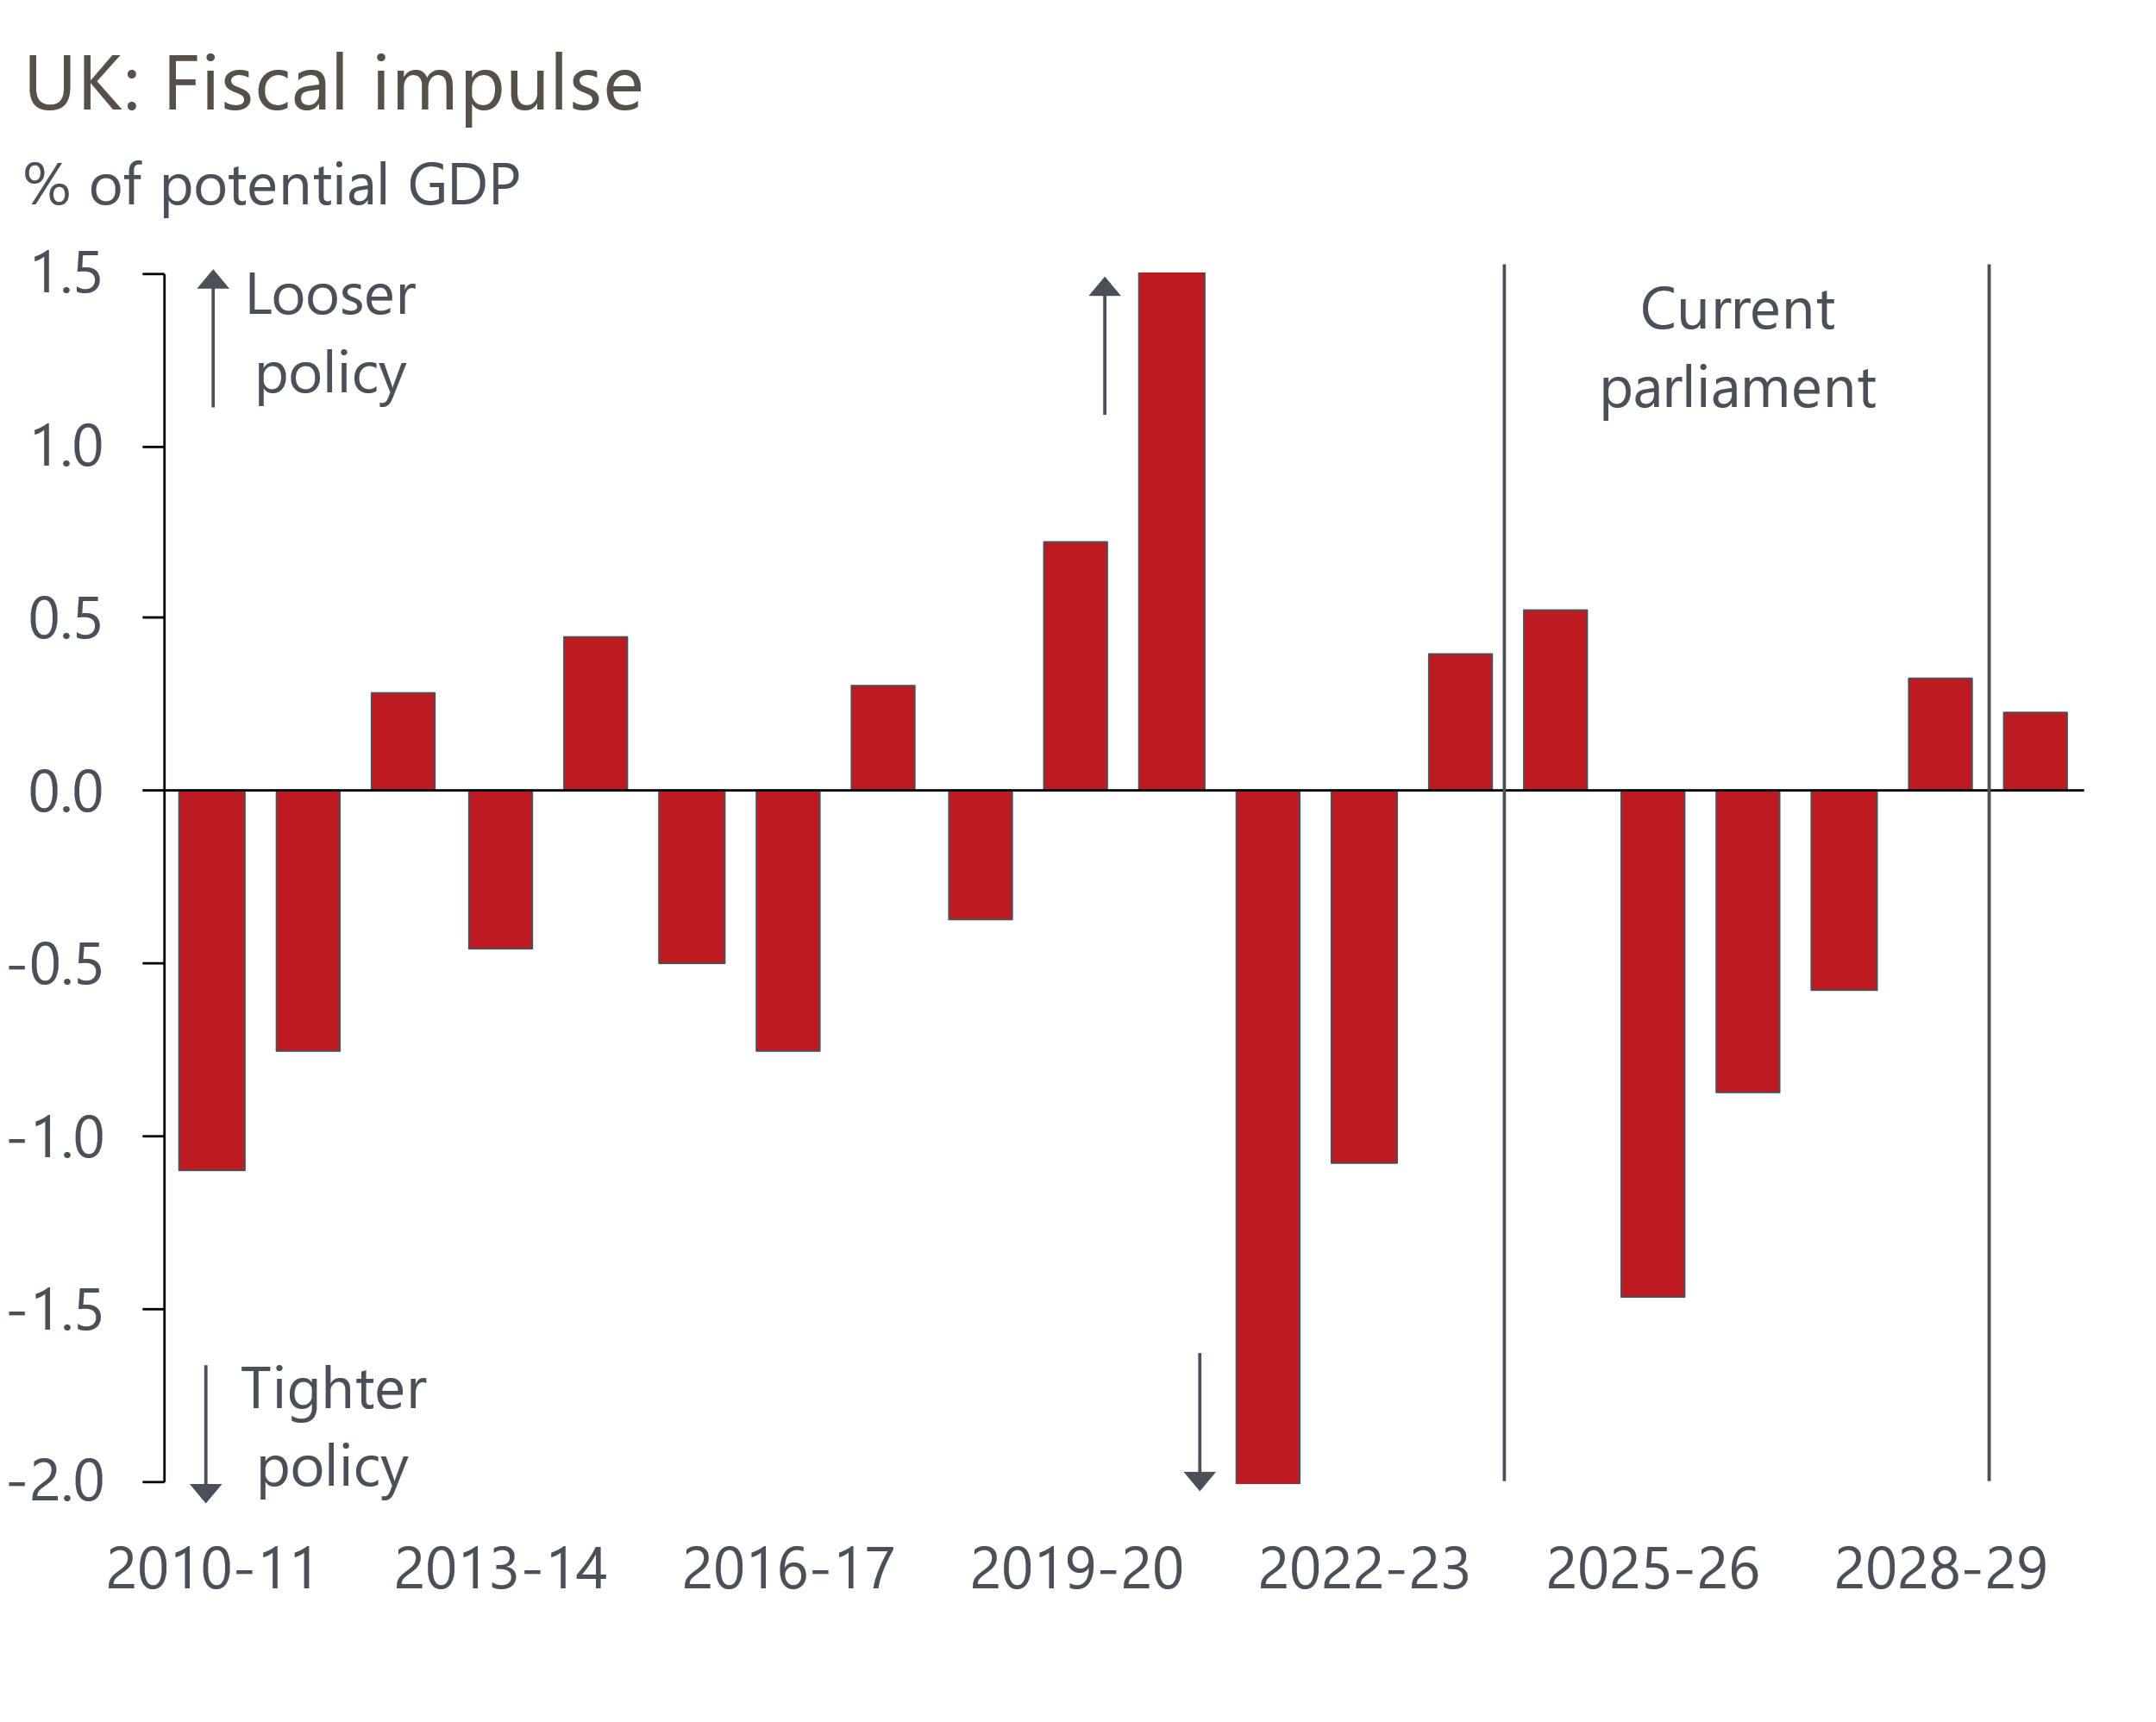
Sources: Oxford Economics, Haver Analytics
The bulk of the tightening is coming from the increase in employers' national insurance contributions and the ongoing freeze in most tax thresholds and allowances. Recent labour market data suggest firms are dealing with the NICs increase via a combination of reducing headcount and authorising lower pay rises; however, the impact has been modest in both cases.
Firms have been able to push some of the extra cost burden onto consumers by putting up prices. This has added to pressures from rising food prices and April's large increases in regulated prices. As a result, we now expect CPI inflation to briefly touch 4% in September and remain above 3% until next April. The combination of slowing pay growth and persistent inflation will cause real wage growth to slow sharply (Chart 3).
Chart 3: After a strong period, household finances are being squeezed by higher inflation
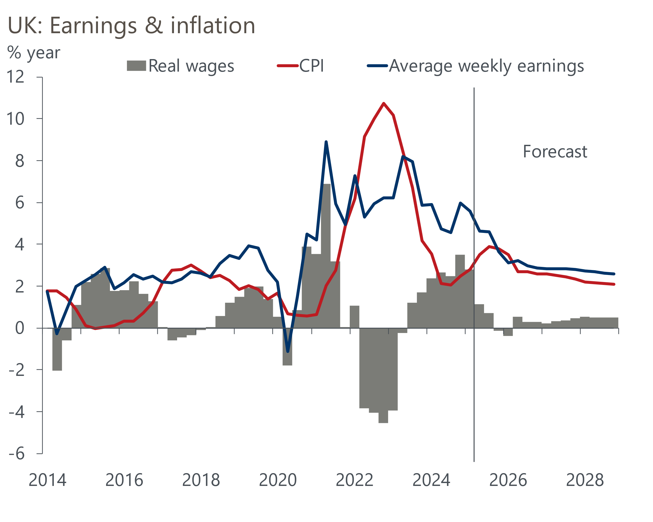
Sources: Oxford Economics, Haver Analytics
Some consumers will have to contend with the lagged impact of past interest rate hikes. More than half of outstanding mortgages are on five-year fixed-rate deals, and as their old deals come to an end, homeowners have been gradually refinancing at much higher interest rates over the past three years.
This process has another couple of years to run. In 2021, quoted five-year fixed-rates for 75% loan-to-value mortgages averaged 1.58%, and we estimate that when these borrowers refinance next year, the average interest rate on an equivalent product will be 270bps higher. Borrowers on the standard variable-rate or refinancing shorter fixes should see their interest rate fall. But we forecast that the average interest rate on the outstanding mortgage stock will rise by around 20bps by the end of 2026. This would represent a smaller increase than those seen in recent years but highlights that monetary policy remains quite restrictive.
Meanwhile, interest receipts will continue to fall back in response to cuts to Bank Rate. So, net interest income will increasingly weigh on household incomes in the near term.
While we're optimistic that households will shed some of the extreme caution that's characterised the past couple of years, the extent to which real income growth is likely to slow means we expect consumer spending to continue to grow at an annualised pace of around 1%.

External environment looks less fragile
The malign effects of tariffs via their squeeze on US households' real incomes and weaker capital spending due to greater uncertainty are only just being felt. But the external environment is set to hold up better than what appeared likely in the spring.
US tariff payments, though rising, are still lower than the effective tariff rate implied by the various policy shift announcements. And the lack of retaliation by most other countries means they won't suffer real income squeezes because of tariff changes.
The various trade agreements announced by the US government brought more clarity and news-based measures of trade policy uncertainty (TPU) fell accordingly, although they remain well above the previous peak in 2018. Our baseline forecast assumes that TPU continues to fall over the next year, settling at the average level seen during President Donald Trump's first term.
This points to a smaller drag on UK business investment than seemed likely in the immediate aftermath of April's 'liberation day' announcements. Still, given that corporate profitability is particularly weak, we don't expect to see any meaningful growth in capital spending over the next 18 months.
The impact of US tariffs on global growth should be mitigated by supportive fiscal and monetary policy, particularly in the US and China. While we expect softer global growth in H2 than in H1, followed by lacklustre growth in 2026, we think the global economy is unlikely to fall into recession.

Budget likely to bring further tightening of fiscal policy
It promises to be a challenging autumn for policymakers. Recent media speculation that the UK could face a repeat of the 1970s International Monetary Fund bailout exaggerates the scale of the UK's fiscal problems. But the UK has one of the higher budget deficits in the G7 and, though it has a plan to reduce borrowing, history suggests that tax-based consolidations have a high failure rate. Plus, the UK cannot fall back on some of the favourable structural factors that allow other countries to fund higher debt levels.
In this context, it's no surprise that investors have a poor view of UK fiscal prospects. Much of the media attention has focused on the 30-year yield, which recently reached its highest level since the late-1990s. The increase in this portion of the curve appears to have been exaggerated by lower structural demand from pension funds. We expect the Bank of England to go some way towards addressing this problem later this month, cutting supply by lowering its target for quantitative tightening and focusing active sales on short and medium, rather than long, gilts. But in any case, the rise in long-dated yields has limited implications for financing government debt – since the government came to power last summer, only 3% of gilts issued were at maturities of 30 years or more.
However, there's also been a clear increase in yields across the middle of the curve, with the 10-year yield up around 25bps on the level seen after last year's budget (Chart 4). Spreads against US Treasuries and German bunds are towards the top of the range seen over the past few years.
Chart 4: Gilt yields rose sharply over the past year, particularly at the longer end of the curve
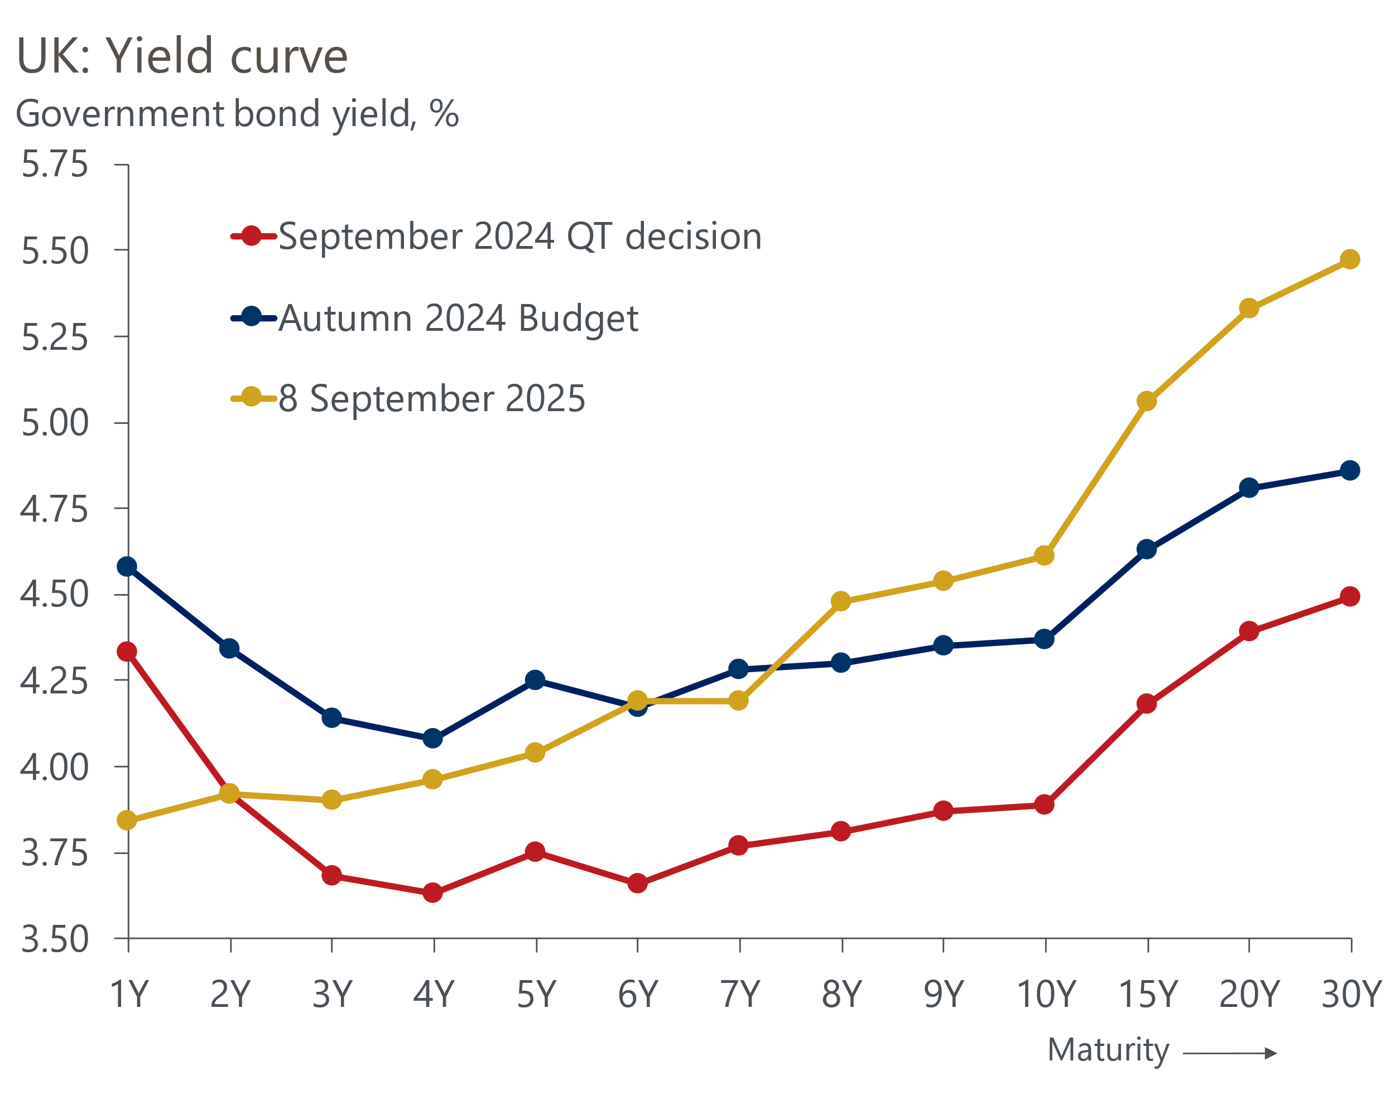
Source: Haver Analytics
This leaves the UK vulnerable to additional swings in market sentiment, making it even more important that the government's deficit-reduction plan proves successful. It will also pose a problem for Chancellor Rachel Reeves as she prepares the Budget, which will be presented on November 26. The Office for Budget Responsibility will lock in its financial market assumptions in a little more than month, and as things stand, we calculate that the increases in gilt yields and market expectations for Bank Rate since the Spring Statement will add nearly £5bn to debt servicing costs in 2029-2030, the target year for the fiscal rules.
On its own, the increase in debt servicing costs would wipe out almost half of the £9.9bn headroom the chancellor had against her borrowing rule. The remainder of the headroom disappears when the government's reversal of welfare reforms and U-turn on giving winter fuel payments to some pensioners are considered. Experience suggests the government will also opt against increasing fuel duty in the Budget, which will add to borrowing.
But these factors could pale in comparison with the impact of the OBR cutting its optimistic potential output forecasts. In a recent note, we estimated that the OBR could cut its projection for potential output in 2029-2030 by 1%-1.4%, which would increase its borrowing forecast by £12bn-£20bn.
Just to comply with the fiscal rules using the same wafer-thin headroom as the last two fiscal events, the Chancellor will likely need to tighten fiscal policy by around £30bn. Assuming recently announced departmental spending allocations for the period to 2028-2029 will not be revised, the only scope to cut spending is in 2029-2030. Markets would not look favourably on any watering down of the fiscal rules, ruling that option out.
Therefore, hefty tax increases look likely. The government appears keen to stick to its 2024 election manifesto commitments not to increase national insurance; the basic, higher, or additional rates of income tax; and VAT. It will probably blur the lines on those commitments by extending the freeze on most tax thresholds and allowances for another couple of years beyond 2027-2028 – a tax rise in all but name. But beyond that, it will likely be forced to re-run the playbook from last year's Budget, raising money by targeting a range of narrowly focused taxes.
This combination might limit the impact on near-term growth prospects. But we are sceptical that these types of measures would ultimately raise the type of money the Treasury thinks it will, and there's a high risk that markets will be similarly unconvinced. The experience of last year suggests the approach could also cause the government substantial political challenges.
In a forthcoming series of notes ahead of the Budget, we plan to look at the fragility of the UK fiscal situation, what the government is likely to do in the Budget, and what the government should do to rectify the problems.

We expect the MPC to slow the pace of rate cuts
Since the Monetary Policy Committee started to cut Bank Rate last summer, it has moved at a steady 'cut-hold' tempo. But its accompanying commentary has been far more erratic, particularly across the past three meetings. Still, its latest mood switch seems to be more decisive, with concerns about the strength of growth and the labour market put on the back burner and the committee placing a renewed focus on the risk of above-target inflation persisting.
The MPC's inflation concerns are two-fold: evidence of weaker pay growth has yet to manifest itself in lower inflation, particularly in the services sector; and high headline inflation this autumn might push up inflation expectations among households and firms, particularly given recent upward pressures from the food and fuel categories, which have high salience.
While the MPC has been clear that it still expects to cut Bank Rate further, the timing and pace of those cuts have become less certain. We think it unlikely that the data will surprise in a way that encourages the four more hawkish members to change tack and back a rate cut in November. So, all five remaining members would need to vote for looser policy to secure another cut at that meeting. As things stand, market pricing implies a probability of just 20% that rates will be cut by November. If that holds, we think it's unlikely that the Governor will be prepared to vote against market pricing, particularly given that any tightening of fiscal policy will not have been announced at that stage. Our new forecast assumes the MPC won't cut Bank Rate again this year, although the November and December decisions will likely be close calls.
We expect rate cuts to resume in 2026. By then, the MPC will likely have to factor in the prospect of tighter fiscal policy. We expect growth to disappoint the BoE's forecasts. And we think there will be better news on wages and inflation, with it becoming apparent to the MPC that the increase in NICs played a bigger role in this year's stickiness in services inflation.
Still, we think the MPC is likely to move slowly, particularly as it moves closer to the range that it considers to be equivalent to a neutral policy rate. We now expect just two 25bp rate cuts in 2026, taking Bank Rate to 3.5% at the end of the year. This is 50bps higher than our August forecast but still a little below current market expectations (Chart 5). Nevertheless, if growth comes in even weaker than we anticipate, or there's clearer evidence that weaker pay growth is pushing down on underlying inflationary pressures, the MPC might opt to switch up the tempo of rate cuts again.
Chart 5: We expect the MPC to cut Bank Rate to 3.5% by the end of 2026, below market expectations
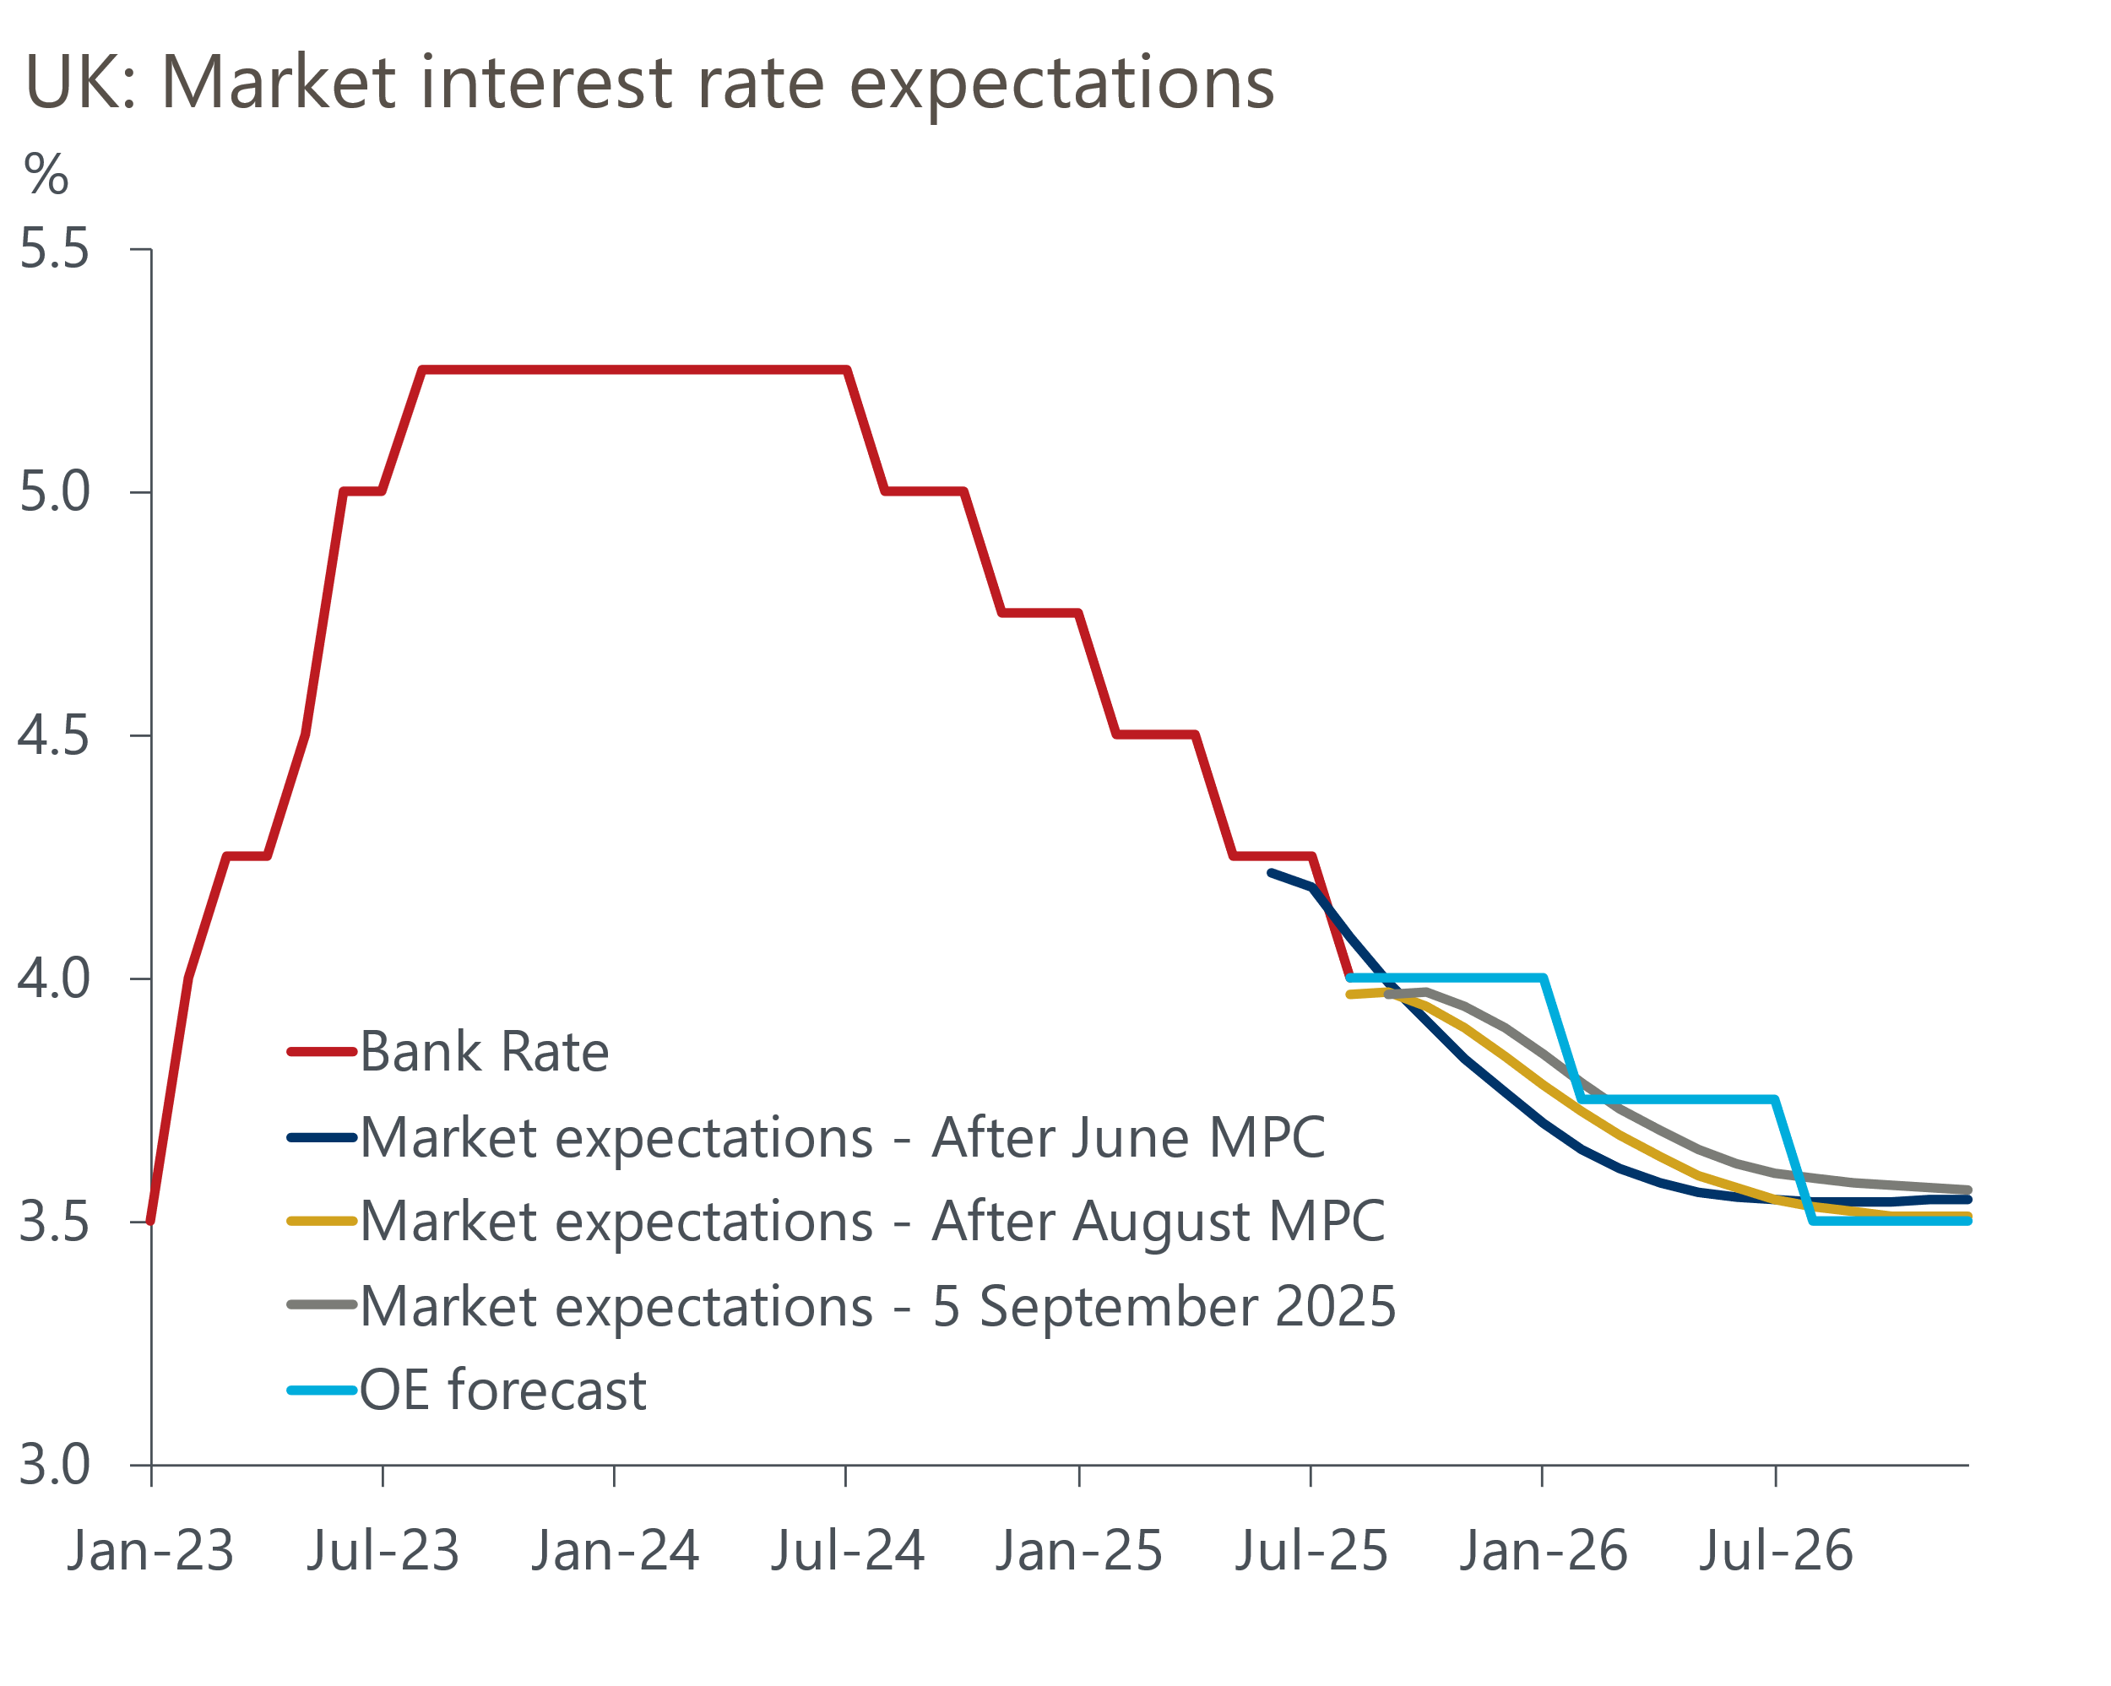
Sources: Oxford Economics, Haver Analytics

